PERSONAL FINANCE MANAGER
@CREATIVITY THINK (9483175986/7019689991)

ABSTRACT:
The Personal Finance Manager is a web-based system designed to help individuals, students, and families monitor and manage their financial activities efficiently. The platform enables users to log income and expenses, create budgets, visualize financial data through charts, generate reports, and receive alerts when goals or budget limits are approached. The system incorporates a secure backend developed using Springboot Framework, and an interactive frontend built with React and Recharts. With features tailored for comprehensive financial monitoring, the system promotes better financial awareness, discipline, and long-term stability for its users..

INTRODUCTION OF THE PROJECT:
Managing personal finances requires consistent tracking, planning, and evaluation of financial activities. The Personal Finance Manager provides an accessible and user-friendly interface that enables individuals to manage income, expenses, budgets, and financial goals. Equipped with visual analytics and alert mechanisms, the system assists users in understanding their financial patterns and making informed decisions. Administrators can configure financial categories and review analytics reports to enhance the platform’s functionality. Built using Sprig for backend processing and React for dynamic user interaction, the system supports secure and efficient financial management suitable for everyday users..

PROJECT OBJECTIVES:

• To create a centralized platform for managing personal finances
• To enable users to track income and expenses accurately
• To provide budget creation and monitoring features
• To offer visual insights through charts and financial reports
• To generate alerts for budget limits and financial goals
• To improve financial awareness among individuals and families
• To ensure secure data storage and easy access to financial records

PROBLEM OF THE STATEMENT:
Individuals often struggle with maintaining consistent financial records, resulting in overspending, unclear budgeting, and lack of long-term planning. Traditional manual tracking methods are prone to errors, time-consuming, and lack visual insights. Users also face challenges in recognizing spending patterns and achieving financial goals without systematic monitoring. The Personal Finance Manager solves these issues by providing an automated, structured, and analytics-driven platform where users can record transactions, set budgets, view detailed charts, generate reports, and receive alerts—ultimately helping them make better financial decisions and stay on track with goals..

MOTIVATION OF THE PROJECT:

• Increasing need for personal financial discipline
• Lack of user-friendly tools for household financial tracking
• Growing demand for visual insights into spending patterns
• Need to simplify budget planning for non-technical users
• Encouraging individuals to develop long-term financial goals

BLOCK DAIGRAM OF PROJECT:

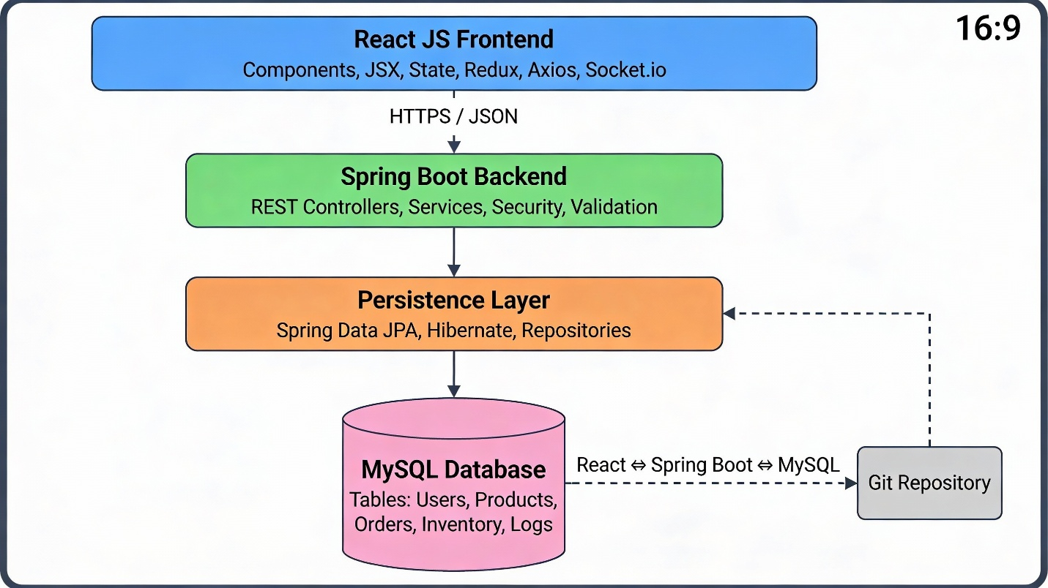

WORKING OF THE PROJECT:

Users begin by registering or logging into the Personal Finance Manager to access their personalized dashboard. They can log incoming and outgoing financial transactions, create monthly or custom budgets, and monitor their progress through graphical charts generated from real-time data. The system continuously evaluates user activity and provides alerts when expenses exceed budgets or when savings goals are near completion. Administrators manage financial categories used by users, review goal statistics, and examine system-wide reports. The backend handles secure authentication and data operations, while the frontend offers a clean and interactive experience for users.

SOFTWARE REQUIREMENT:
- Backend:
  - Jaxa
  - SpringBoot
  - SQLite/PostgreSQL
- Frontend:
  - React.js
  - Axios
- Development Tools:
  - Visual Studio Code
  - Postman (for testing APIs)
  - Git/GitHub (for version control)
- Server/Deployment (Optional):
  - Gunicorn, Nginx, or Heroku/AWS for hosting

ADVANTAGES OF THE PROJECT:

• Enables efficient tracking of income and expenses
• Provides real-time visual financial insights
• Helps users maintain budgets and avoid overspending
• Generates alerts for improved financial discipline
• Offers detailed financial reports for analysis
• Supports goal-based financial planning
• Enhances financial awareness for individuals and families
• Secure, scalable, and easy-to-use system

APPLICATIONS OF THE PROJECT:

• Personal budgeting for individuals
• Household financial planning for families
• Student financial management
• Small-scale financial monitoring for freelancers
• Goal-based savings tracking
• Expense tracking for home-based businesses
• Monthly or yearly financial reporting
• Financial habit improvement and awareness

REFERENCES:

- React. React Official Documentation. Available: https://reactjs.org/docs/getting-started.html
- Redux. Redux Documentation. Available: https://redux.js.org/introduction/getting-started
- PostgreSQL Global Development Group. PostgreSQL Documentation. Available: https://www.postgresql.org/docs/
- MySQL. MySQL Reference Manual. Available: https://dev.mysql.com/doc/
- Git. Git Documentation. Available: https://git-scm.com/doc
- Node.js. Node.js Documentation. Available: https://nodejs.org/en/docs/
- Axios. Axios Documentation. Available: https://axios-http.com/docs/intro
- Socket.io Documentation – https://socket.io/docs/

